About the Project
This project implements a reusable Python module that provides Create and Read functionality for a MongoDB database. The module connects to the Austin Animal Center (AAC) Outcomes dataset that was imported in a previous milestone and allows records to be inserted and queried using Python.
The module is written using object-oriented programming principles so it can be imported and reused by other scripts or applications, including future dashboard projects.
Motivation
The goal of this project is to separate database access logic from application logic. By creating a standalone CRUD module, database operations become easier to reuse, test, and maintain. This approach reflects common industry practices and prepares the project for expansion in later milestones.
Usage
The CRUD module is imported into a Jupyter Notebook testing script and instantiated as an object. The module provides methods to create new records and read existing records from the MongoDB collection.
Create Operation
The create() method inserts a new document into the animals collection and returns True if the operation is successful.
Example:
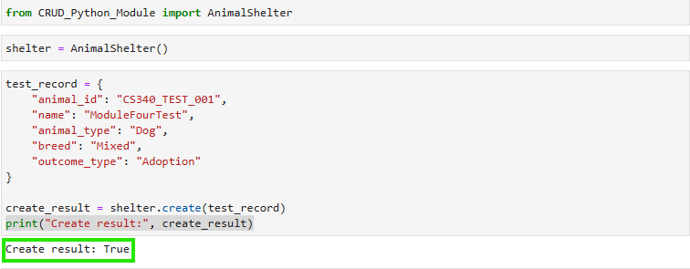

Read Operation
The read() method queries the collection using MongoDB’s find() operation and returns the results as a list.
Example:
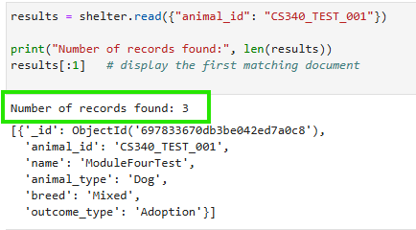
Installation
The following tools were used to complete this project:
- Python 3 – Primary programming language
- MongoDB – NoSQL database used to store AAC data
- PyMongo – MongoDB driver for Python
- Jupyter Notebook (Codio) – Used to test and demonstrate functionality
These tools were selected because they integrate well and are commonly used in database-driven applications.
Getting Started
To reproduce this project, the AAC dataset must be imported into MongoDB using the aac database and animals collection. A database user (aacuser) with read and write permissions was created during the Module Three milestone.
The Python CRUD module initializes the MongoDB connection in its constructor and includes Create and Read methods. During testing, an authentication issue was encountered because the user account was created in the admin authentication database. This was resolved by adding authSource=admin to the MongoDB connection string.

Conclusion
This README documents a Python CRUD module that successfully implements Create and Read operations for a MongoDB database.

